**Informatica Project**

**Project 1**. To Calculate the Customerwise Revenue by using the Customer_Master,SalerOrderHeader and SalerOrderDetails Data sources.Target Table: Customer_Wise_Revenue Target Columns : Customer_id,Customer_name(First_name.Middle_name,Last_name),Order_date,Total_Qty,Total_Revenue,Created_By,Created_Date.Modified_by, Modified_date

Solution:

Source:

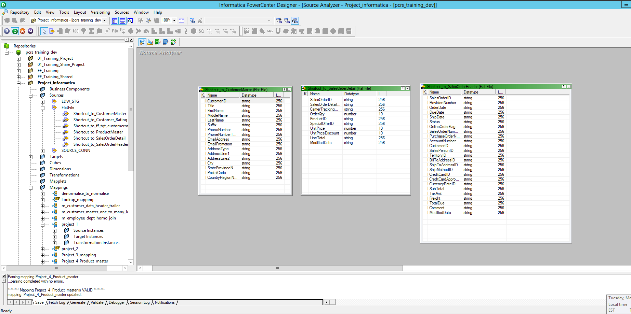

Target:

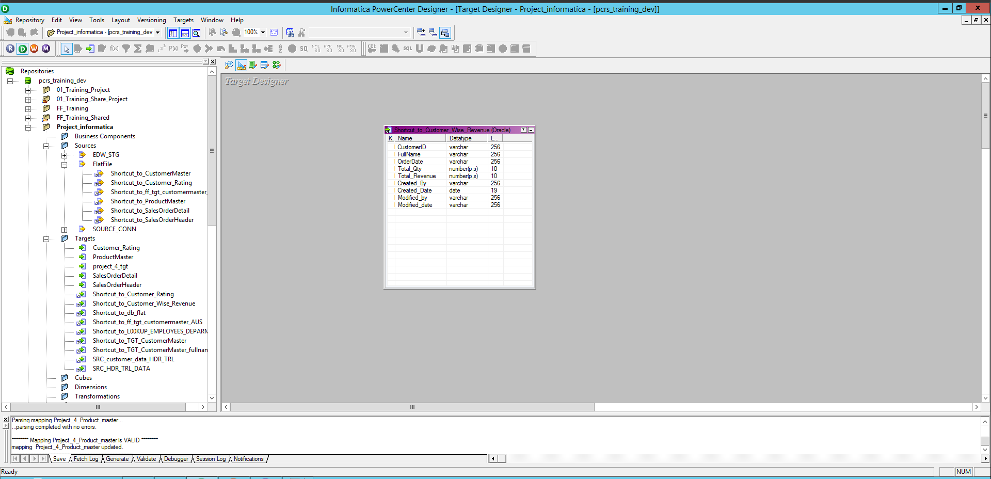

Mapping:

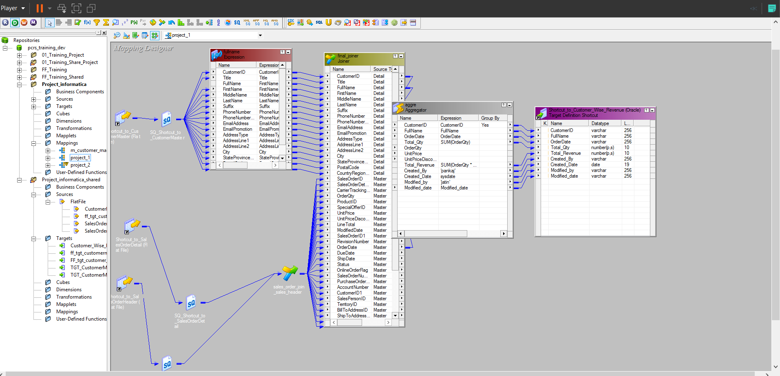

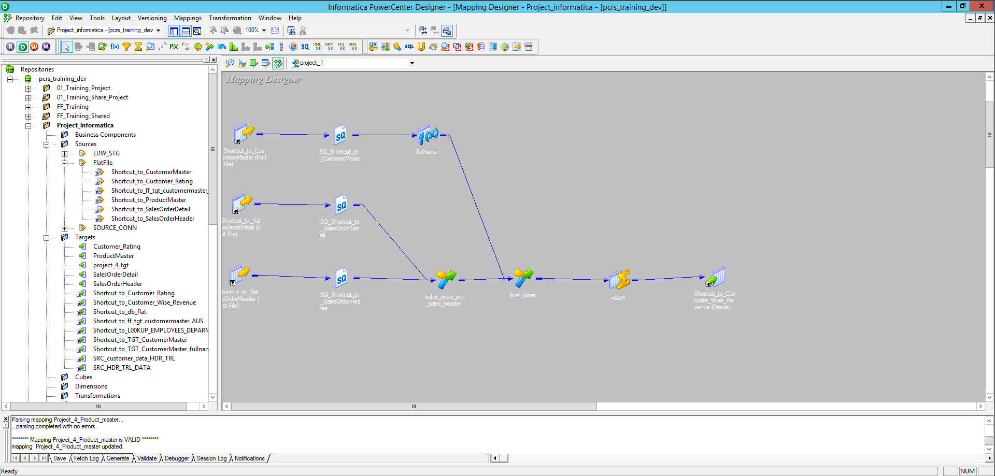

Workflow:

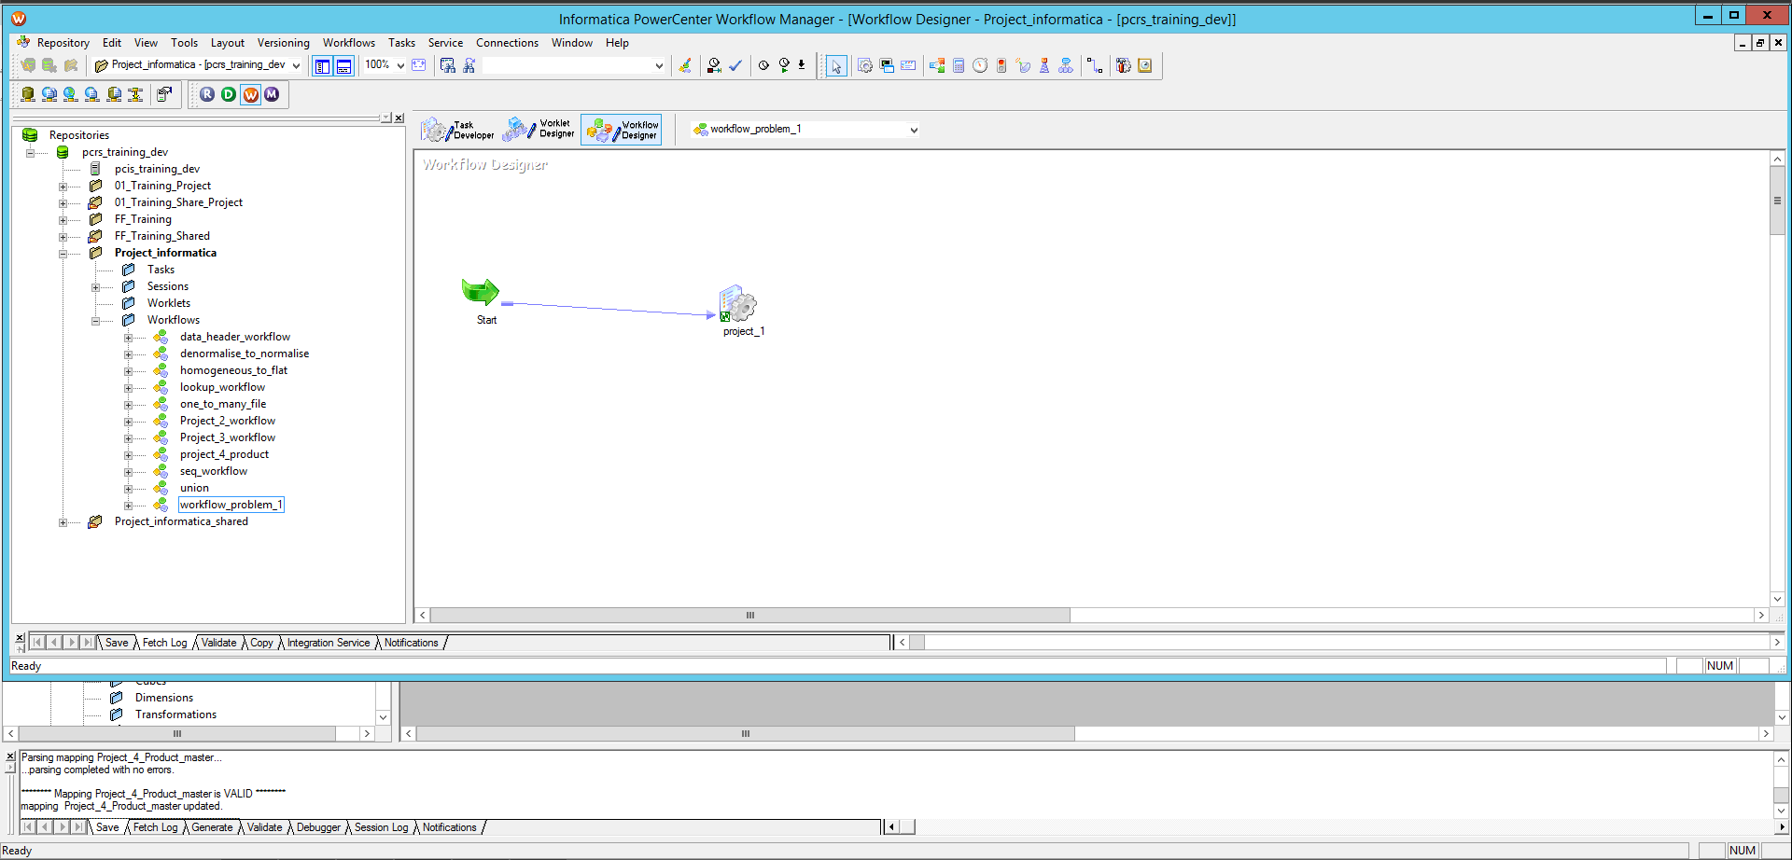

Monitor:

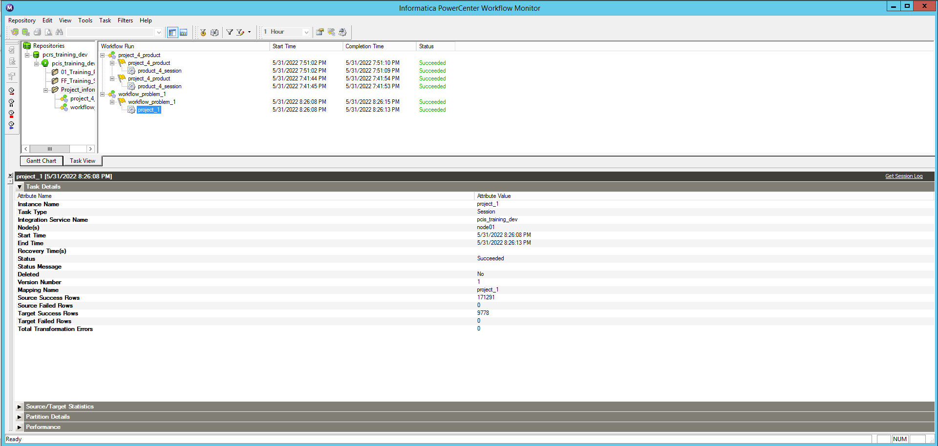

Output:

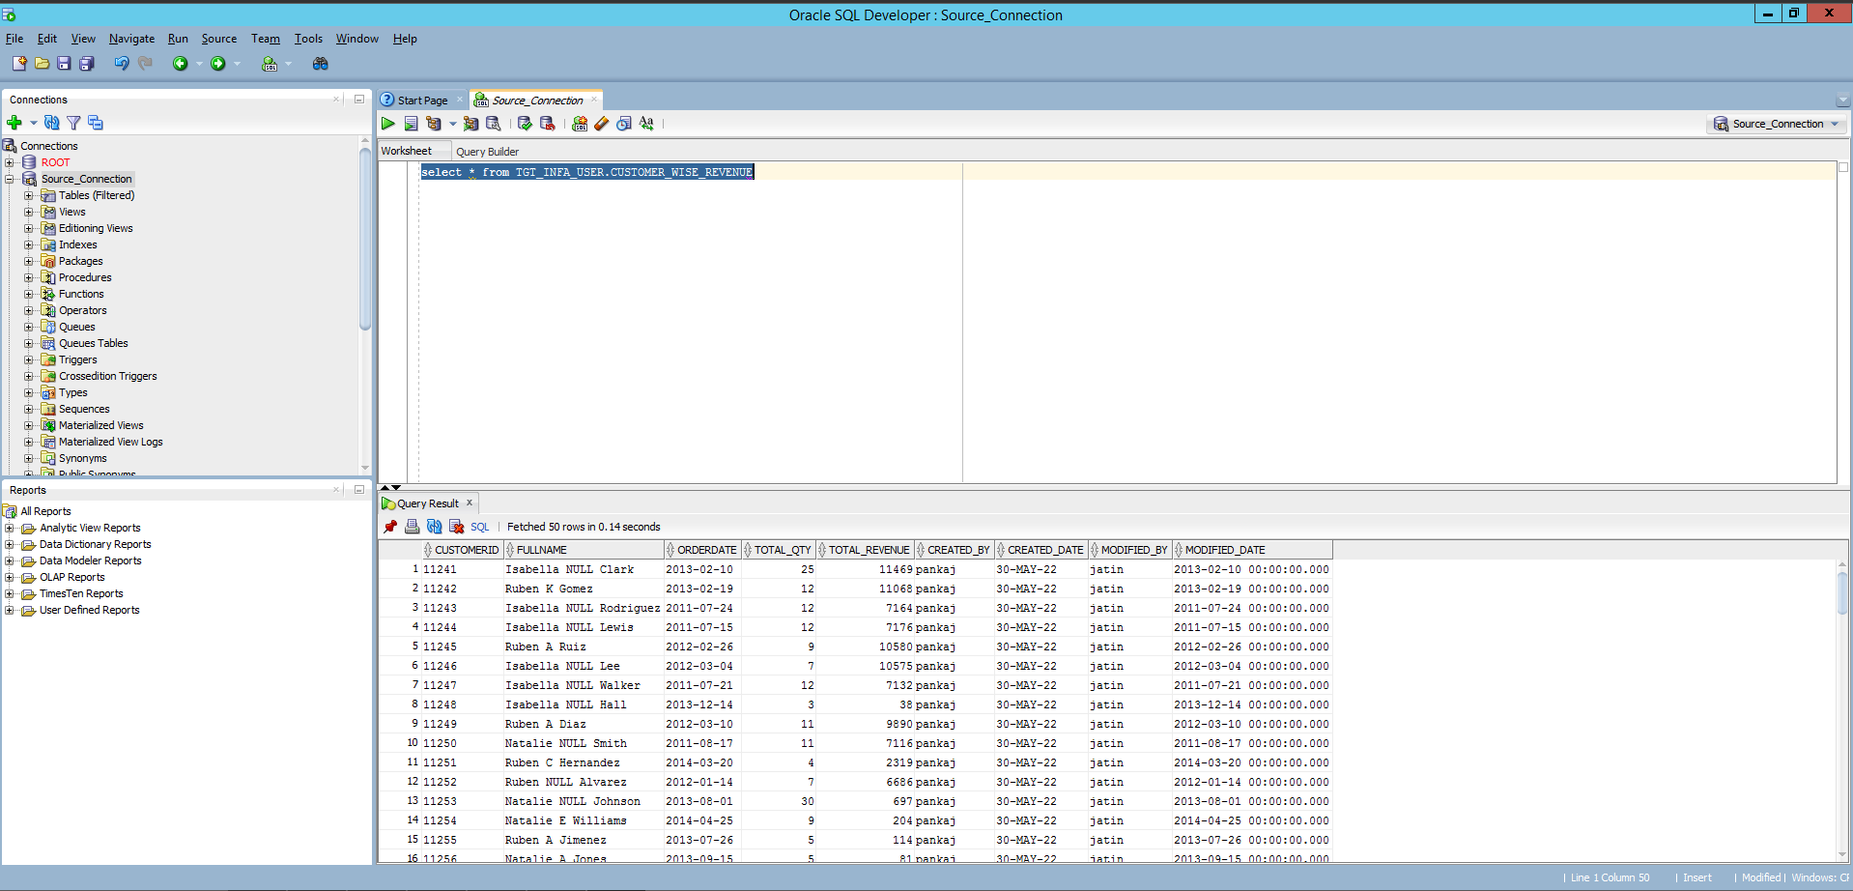

**Project 2:**

We receive feed from multiple sources for region wise Customer data in the form of flat file. The files are received at inbound folder (Source Directory) of your Informatica server. Design an ETL job, which will read those files from the folder and will load the data into the table DIM_CUSTOMER target system.  
Hints:  
ϖ Sample Input Files are  Customer_Data_USA.txt,Customer_Data_UK.txt,Customer_Data_India.txt, Customer_Data_France.txt etc  
ϖ Use indirect mode to load all the files using a single job  
ϖ Use Command task to generate the file list .

**Source:**

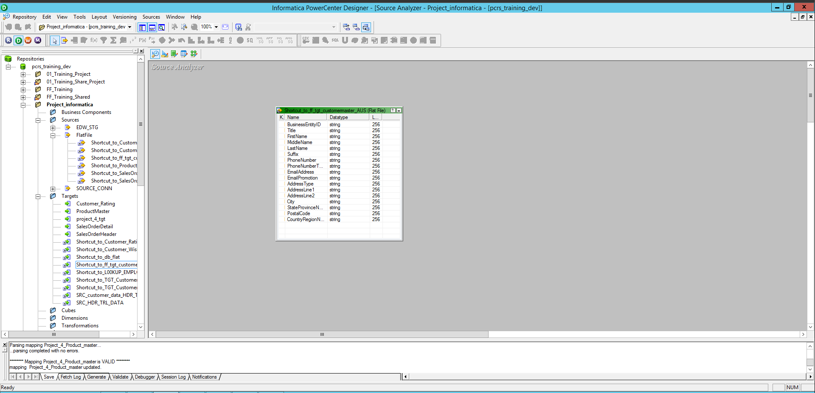

**Target:**

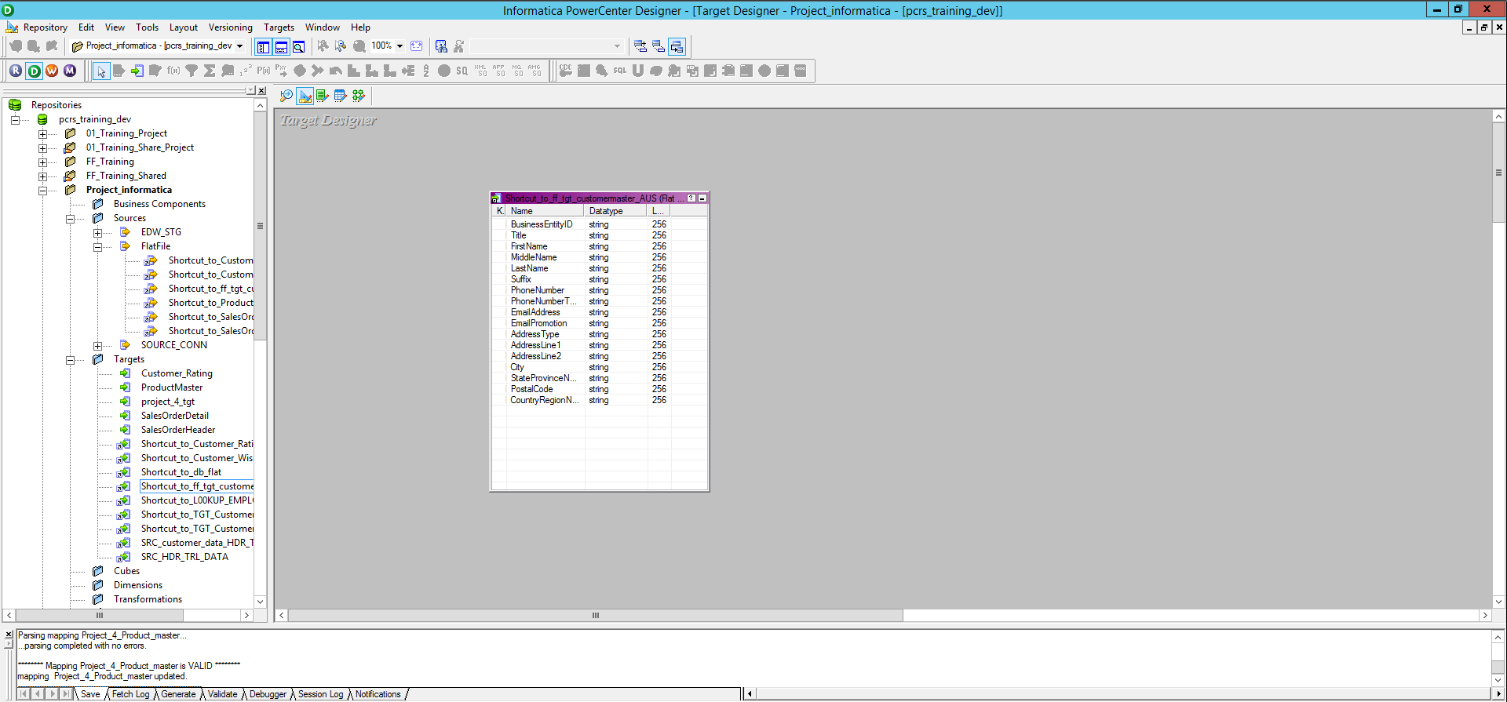

**Mapping:**

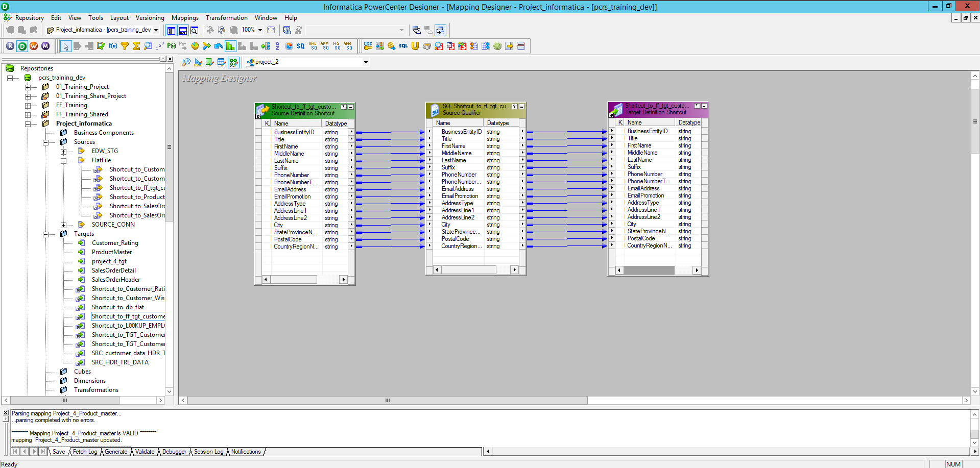

**Workflow:**

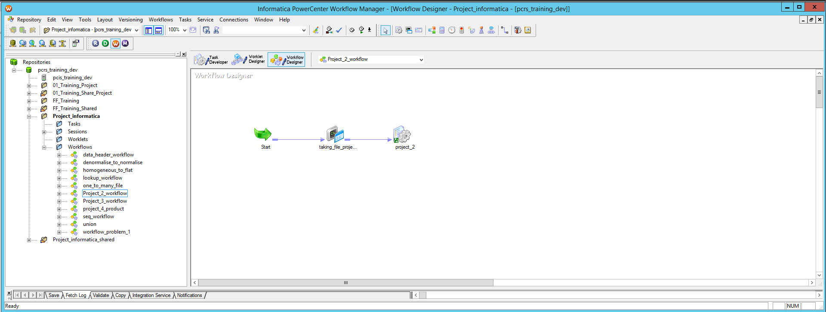

**Monitor:**

